Computation Graph in Python

The Purpose of this task, is to create a program written in Python (preferably 3) that calculates a propagated statistic in a DAG (Directed Acyclic Graph).

The program will receive a path for a json-formatted file path, and will print the result to the standard output (number only).

You can assume that the input is valid (file exists, valid json and valid input graph).

Please free to use any available python libraries, for example:

* json: for parsing json input
* argparse: for parsing command line arguments
* networkx: for graph related algorithms

Input:

* Directed Acyclic Graph with single source, named `root`, represented as JSON string
* Each node contains a number (floating point, greater than 1) which represents an error.

Expected output:

* The sum of all leaf nodes accumulated errors (AE)

The accumulate error of a node, is defined by the sum of errors of its inputs, plus the error of the current node multiplied by its distance from the source node plus one.

Examples:

1.

[

"root": { "nodes": [],"error": 1.3 }

]

Represents the graph:

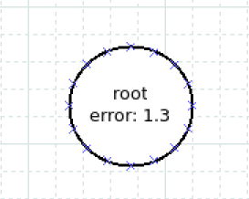

It has only one leaf, and its accumulated error is the sum of all accumulated errors of its input (0) plus the error multiplied by its **minimum** distance from the source plus 1.

Therefore, the output should be 1.3

2.

[

"root": { "nodes": ["b", "c"], "error": 1.3 },

"b" { "nodes": ["c", "d"], "error": 1.1 },

"c" { "nodes": [], "error": 1.2 },

"d" { "nodes": [], "error": 1.7 }

]

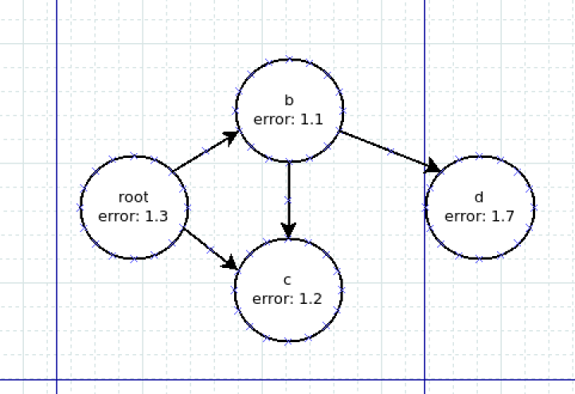

In this example there are 2 leafs, “c” and “d”

Let’s calculate each node’s accumulated error:

AE(“root”): 1.3 * (0 + 1) = 1.3

AE(“b”) : 1.1 * (1 + 1) + AE(“root”) = 2.2 + 1.3 = 3.5

AE(“c”) : 1.2 * (**1** + 1) + AE(“root”) + AE(“b”) = 2.4 + 1.3 + 3.5 = 7.2

AE(“d”): 1.7 * (2 + 1) + AE(“b”) = 5.1 + 3.5 = 8.6

Therefore, the sum of all leafs accumulated errors is 7.2 + 8.6 = 15.8

Delivery

* All python code files
* 2-3 json examples for graphs with different length/topology

Contact

For clarification please contact [miki.koffman@samsung.com](mailto:miki.koffman@samsung.com)

Good luck.